1. Write a C Program to print odd numbers of n terms and display their sum

#include <stdio.h>

int main() {

int n,count=0,sum=0,i=0;

printf("Enter the limits of the range: ");

scanf("%d",&n);

while(count<=n){

if(i%2!=0){

printf("%d\t",i);

sum+=i;

count++;

}

i++;

}

printf("\nThe sum of the range of odd numbers is %d",sum);

return 0;

}

Output:

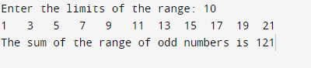

2 . Write a C Program to get ten numbers from the user and display them

#include<stdio.h>

int main(){

int arr[10];

printf("Enter 10 numbers: ");

for(int i=0;i<10;i++){

scanf("%d",&arr[i]);

}

for(int i=0;i<10;i++){

printf("%d\t",arr[i]);

}

return 0;

}

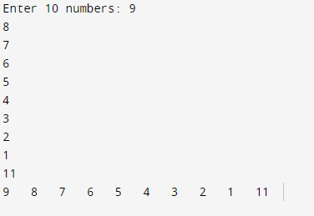

1. Write a C Program to get ten numbers from the user and display them in reverse order

#include<stdio.h>

int main(){

int arr[10];

printf("Enter 10 numbers: ");

for(int i=0;i<10;i++){

scanf("%d",&arr[i]);

}

for(int i=9;i>=0;i--){

printf("%d\t",arr[i]);

}

return 0;

}

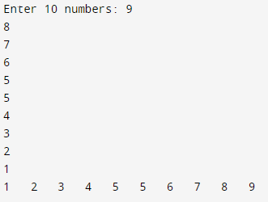

4.Write a C program to get 10 names from the user and display those names using array

#include<stdio.h>

int main(){

char names[10][50];

for(int i=0;i<10;i++){

printf("\n Enter the Name-%d: ",i+1);

scanf("%s",&names[i]);

}

for(int i=0;i<10;i++){

printf("\n Name - %d : %s ",i+1,names[i]);

}

}

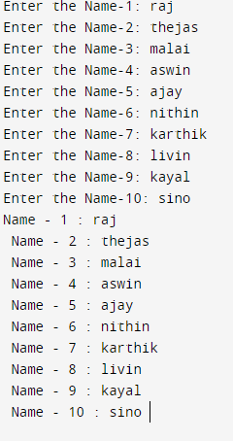

5.Write a C Program to get ten numbers from the user and display the sum of the elements in the array

#include<stdio.h>

void main(){

int sum=0,array[10];

for(int i=0;i<10;i++){

printf("Element-%d: ",i+1);

scanf("%d",&array[i]);

}

for(int i=0;i<10;i++){

sum+=array[i];

}

printf("The sum of the elements in the array is %d",sum);

}

